Question 1: Mapping Data onto Aesthetics
1. Write an R program
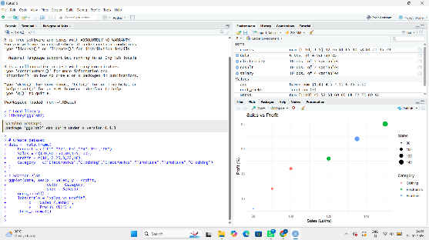
2. Map Category using an appropriate aesthetic and Sales using another suitable aesthetic.
- Category → Color (categorical variable)
- Sales → Size (continuous variable)
3. Interpret the relationship between Sales and Profit.
The scatter plot shows a positive relationship between Sales and Profit. Products with higher sales generally have higher profit percentages.
4. Identify the type of scale used for each variable.
- Sales → Continuous scale
- Profit → Continuous scale
- Category → Categorical (Discrete) scale
5. Suggest one alternative visualization that better represents the same data.
A bubble chart or a grouped bar chart can also effectively compare Sales, Profit, and Category.
Question 2: Coordinate Systems (Cartesian and Polar)
1. Write an R program to visualize using a Cartesian coordinate system.
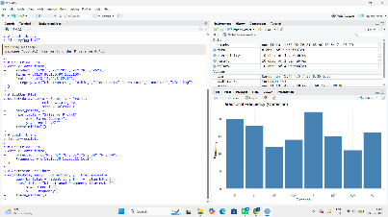
2. Write another R program using a Polar coordinate system.
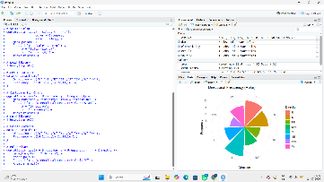
3. Compare the effectiveness of both visualizations.
- Cartesian chart: Easier to compare frequencies accurately.
- Polar chart: Better for showing circular or directional patterns but less accurate for comparing values.
4. Which coordinate system is more appropriate for directional data?
The Polar coordinate system is more appropriate because it naturally represents directions around a circle.
5. Justify your answer.
Directional data (North, South, East, West, etc.) are circular in nature. A polar chart preserves this relationship, making it easier to understand directional patterns.
Question 3: Color Scales for Data Representation
- Write an R program to create a bar chart using a sequential color scale.
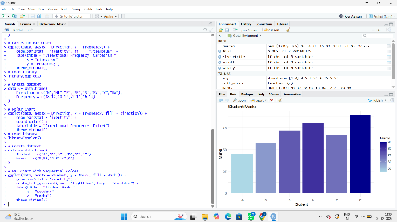
2. Identify the students with the highest and lowest marks.
- Highest Marks: Student F (90)
- Lowest Marks: Student A (45)
3. Explain why a sequential color scale is appropriate.
A sequential color scale represents ordered numerical values, making it easy to distinguish low, medium, and high marks.
4. Suggest a color palette suitable for color-blind users.
The Viridis color palette is recommended because it is color-blind friendly and easy to interpret.
5. Explain the difference between sequential and categorical color scales.
Sequential Color Scale | Categorical Color Scale
Used for continuous numerical data | Used for categories/groups
Colors vary gradually | Each category has a distinct color
Example: Marks, Temperature | Example: Gender, Region

Question 4: Highlighting with Color
- Write an R program to create a highlighted bar chart.
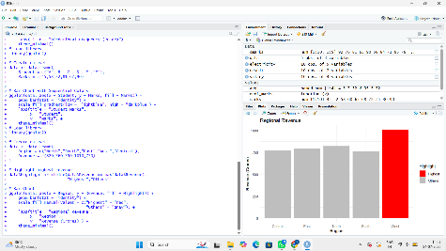

2. Explain how highlighting improves data interpretation.
Highlighting draws attention to important values, helping viewers identify key information quickly.
3. Identify the highest-performing region.
West with ₹1010 Crores.
4. Discuss how excessive use of colors can affect interpretation.
Using too many colors can confuse viewers, reduce readability, and make important information difficult to identify.
5. Suggest one alternative highlighting technique other than color.
Use data labels, annotations, or larger bar size to emphasize important values.
Question 5: Integrated Visualization
1. Write an R program to create a bubble chart.
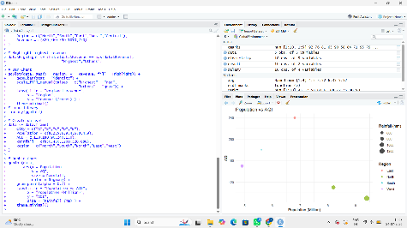
2. Select suitable aesthetics for Population, AQI, Rainfall, and Region.
- Population → X-axis
- AQI → Y-axis
- Rainfall → Bubble Size
- Region → Color
3. Interpret the relationship between Population and AQI.
There is no strong linear relationship between Population and AQI. Some cities with larger populations have lower AQI, while others have higher AQI.
4. Identify the continuous and categorical variables.
Continuous Variables:
- Population
- AQI
- Rainfall
Categorical Variables:
- City
- Region
5. Recommend one improvement to enhance the visualization's readability.
Add data labels (city names) and use a color-blind-friendly palette (Viridis) with a clear legend to improve readability.

